**An Art Gallery Management System**

**BY**

**SERAS RATNA KANSAKAR**

**7-2-450-113-2017**

**Thames International College**

*A Summer Project Report Submitted to*

**Faculty of Management, Tribhuvan University**

in partial fulfillment of the requirements for the degree of

**Bachelor of Information Management**

New Baneswor, Kathmandu

August 31, 2021

**STUDENT DECLARATION**

This is to certify that I have completed the Summer Project entitled “**An** **Art Gallery Management System**” under the guidance of Mr.Chandan Nayak sir in partial fulfillment of the requirements for the degree of **Bachelor of Information Management** at Faculty of Management, Tribhuvan University. This is my original work and I have not submitted it earlier elsewhere.

Date:

Signature:

Name: Seras Ratna Kansakar

**i**

**CERTIFICATE FROM THE SUPERVISOR**

This is to certify that the summer project entitled “**An** **Art Gallery Management System**” is an academic work done by **Seras Ratna Kansakar** submitted in the partial fulfillment of the requirements for the degree of **Bachelor of Information Management** at Faculty of Management, Tribhuvan University under my guidance and supervision. To the best of my knowledge, the information presented by him/her in the summer project report has not been submitted earlier.

______________________

Signature of the Supervisor

Name:

Designation:

Date:

**ii**

**ACKNOWLEGEMENTS**

The completion of this project report would not have been possible without the continuous support and guidance of various people and faculty members of Thames International College. Without their help and co-operation, this report would not have been achievable. I would like to extend my sincere gratitude to everyone who has helped me in the completion of this project preparation of this report.

Foremost, I would like to thank Tribhuvan University for giving us this opportunity which allows and helps every BIM student to acquire, understand as well as enhance knowledge on IT platform.

I would like to express my sincere gratitude to our course facilitator Mr. Chandan Nayak for his continuous guidance, suggestions, encouragement and comments for preparation and completion of this project proposal.

At last, but not the least, I am thankful to all my teachers and friends who have been always helping and encouraging me throughout this project.

**iii**

**EXECUTIVE SUMMARY**

Otaku Anime Art Club is a Nepali club consisting of anime art enthusiasts from around the world. The main objective of this club is to provide exposure of different artists from around the world but mostly Nepalese anime artists so that their artworks would get some recognition.

The main problem was that the club was not able to globally attract since it only had a Facebook page and selling of drawings and paintings was not very feasible. So, the main goal of this project is to develop an ecommerce website for the club so that both the client and the users can easily be involved in the buying and selling of the artworks. Another problem faced by the organization was that there was no proper management of data of the artists.

XP Agile Methodology of Software Engineering is used to develop the project. The core language used in completion of the project is PHP. Laravel Framework 7 was used as a framework. The database used is MYSQL. The front end uses HTML, CSS, JavaScript, Bootstrap and jQuery. The project is developed using OOD concepts.

The main benefit that the client will get from this project is the growth of their business as this project will help in expanding the customer reach to the ends of the world where there is access to the Internet. Also, this project will also be purely focused on the end customer experiences including customer login system plus add to cart facilities with on-site order billing system. The system also has special authorities for admin with built-in admin control page.

The project also provides solutions to the company regarding customer interaction and proper management of data and information of the artists as well as the customers. The website will deliver everything clearly and concisely so that the customer’s questions are answered before they can ask them.

Altogether, this project will help in achieving the company’s goal that is to expose the talent of the artists throughout the world and will also help to act as a bridge between the art enthusiasts and the artists along with proper and systematic management of data.

**iv**

**TABLE OF CONTENTS**

**Page**

*Student Declaration i*

*Certificate from the Supervisor ii*

*Acknowledgments iii*

*Executive Summary iv*

*Table of Contents v*

*List of Tables and Figures vi*

*Abbreviations*  *vii*

**Chapter I Introduction**

1.1 Background Introduction of the Organization 1

1.2 Current Situation of the Organization 1

1.3 Problem of the report 1

1.4 Objective of the report 1

1.5 Methodology/Procedure adopted for writing the report 2

**Chapter II Tasks and activities performed**

2.1 Requirement Analysis 3

2.1.1 Data collection 3

2.1.2 Requirement Specification 3

2.1.2.1 Functional requirements 3-4

2.1.2.2 Non-functional Requirements 5

2.1.3 Feasibility study 6

2.2 Planning 7

2.2.1 Resource Requirements 7

2.2.1.1 Minimum Hardware Requirements 7

2.2.1.2 System Requirement 7

2.2.2 Time Scheduling 8

2.3 System Design 12

2.2.1 System Flowchart 13

2.3.2 System Architecture 14

2.3.3 Database Schema Design 15

2.3.4 Interface Design 16

2.4 Implementation and Testing 17

2.4.1 Coding Tools 17-18

2.4.2 Testing 19

**Chapter III Discussions and Conclusions**

3.1 Result and discussion 20

3.2 Conclusion 20

**References 21**

**Appendices 22-28**

**v**

**LIST OF TABLES, FIGURES AND PICTURES**

**Page**

Figure 1.1 XP Agile Methodology 2

Figure 2.1 Gantt chart of Project Overview & Database Design Phase 6

Figure 2.2 Gantt chart of System Development Phase 7

Figure 2.3 Gantt chart of System Testing Phase 8

Figure 2.4 Gantt chart of System Deployment & Report Writing Phase 9

Figure 2.5 Use Case diagram 10

Figure 2.6 Flowchart of the system 11

Figure 2.7 System Architecture 14

Figure 2.8 Database Schema Design 15

Figure 2.9 Interface Design-Home Page 16

**vi**

**ABBREVIATIONS**

HTML : Hyper Text Markup Language

CSS : Cascading Style Sheet

JS : JavaScript

OOP : Object Oriented Programming

HTTP : Hypertext Transfer Protocol

SDLC : Software Development Lifecycle

IT : Information Technology

CRUD : Create, Read Update and Delete

MVC : Model View Controller

API : Application Programming Interface

SQL : Structure Query Language

DBMS : Database Management System

Admin : Administrator

XAMPP : Cross-platform(X), Apache(A), Maria DB(A), PHP(P), AND Perl(P)

ASP : Active Server Pages

I/O : Input/Output

CPU : Central Processing Unit

GB : Gigabyte

RAM : Random Access Memory

OS : Operating System

UAT : User Acceptance Testing

UI : User Interface

TDD : Test Driven Development

XP : Extreme Programming

**vii**

**CHAPTER 1**

**INTRODUCTION**

* 1. **Background**

Otaku Anime Art Club is a Nepali club consisting of anime art enthusiasts and Nepalese anime artists. It was founded on April 1, 2020. This club was established with a vision to expose the talent of young Nepalese anime artists and also foreign anime artists to the anime fan base around the world.

* 1. **Current Situation of the Organization**

The organization is currently only able to expose the artists through Facebook and have only been able to post and share their artworks through Facebook. The organizations current vision is to be able to properly expose the artists and act as a medium to connect the art enthusiasts and fans to the artists.

* 1. **Problem of the Report**

The organizations main problem is not being effectively able to provide exposure to the artists in this modern online world. Another problem that I identified was that some of the artists were willing to sell their artworks to their customers and vice versa through the Internet, but the organization was not able to fulfill those requests.

Also, the organization was poorly managed in terms of storing the data and files of the artists which made it difficult for the viewers to find the details of the artists and their artwork they were looking for.

* 1. **Objective of the Report**

The project aims to create a fully functional and dynamic e-commerce website for Otaku Anime Art Club to manage the customers data, manage the artworks that are for sale and help to expose the artists globally. The Project is intended to be a smart solution to the club’s current problems and help to reach millions of artists easily and to increase sales in business.

Now the main objectives of the project are as follows.

* To develop a well-integrated and user-friendly online ecommerce website for the organization.
* To develop a user-friendly website where users can search for products, view a complete description of the products and order the products.
* Provide an Add to and remove from cart feature which allows users to add a product to or remove a product from the shopping cart by the click of a single button.
* To make a user-friendly view that shows all the complete details of the product along with the images of the product.
* Easy registration of new users.
* To make an Admin only accessible control page where admins can add, delete and update products.
  1. **Methodology/Procedure adopted for writing the report**

The project report is created using Microsoft Word 2013 by complying with the TU Report Writing Guidelines. The References is done in APA Style of Referencing.

Finally for the completion this project, XP agile methodology was implemented which ensured smooth and effective functionality and providing the benefit of flexibility. The Agile software development methodology is one of the simplest and effective processes to turn a vision for a business need into software solutions. Also, I decided to go with this methodology because of the following reasons.

* This method proposes incremental and iterative approach to software design.
* Maintaining simplicity through constant refactoring of code.
* In XP, a customer or user is part of the XP team and is responsible for making decisions on requirements.
* It proposes constant code improvement (refactoring) to make changes easier when they have to be implemented.
* It follows Test-First and TDD to check the software codes are executed without any errors.
* The customer has early and frequent opportunities to look at the product and make decision and changes to the project.
* Errors can be fixed in the middle of the project.
* In agile testing when an iteration ends, shippable features of the product is delivered to the customer.
* Regular and rigorous testing is implemented in this method.
* Development process is iterative, and the project is executed in short (2-4) weeks iterations.

3.3-XP-ReleaseCycle.eps

Fig 1.1 XP Agile Methodology

**Chapter II**

**TASKS AND ACTIVITIES PERFORMED**

**2.1 Requirement Analysis of the project**

The main objective of the project is to provide a user-friendly and interactive user interface. Extensive analysis and research have been done to identify the needs and behaviors of various users.

* To provide better interaction and user-friendly website, a navigation bar should be made so that the users can easily navigate their way through the website.
* Also, to enhance the ease of use, users should be able to search for the product by using the product name in the search bar.
* To increase user interaction the user should be able to add the product to the shopping cart by clicking the add to cart button. The user should be able to add and remove multiple products from the shopping cart.
* The users should be able to view the complete details about the product.
* The users should be able to register and logged in to the system. Also, the products added to the shopping cart should remain the same after user session has expired.
* The users should be able to see the full billing amount after they have finalized their ordered products.
* The admins should only be granted the permission to the admin control page where they are able to update, delete and new products.

**2.1.1 Data collection**

The data collected from the customers are mostly from the art enthusiast and anime fans. Data were also directly collected from the artists who showcased their arts in the company. Multiple online surveys were conducted among the users and also direct surveys were done to collect the data.

**2.1.2 Requirement Specification**

This project allows users to purchase products that are listed for sale and accept online payments as well as cash on delivery.

**2.1.2.1 Functional requirements**

Functional Requirements describes functionality or system services in detail. It may be high-level statements of what the system should do. The project’s functional requirements are as follows.

* **Email and password must match to login.**

The email and password entered during registration must match during the login process in order for a user to be logged-in to the system.

* **Passwords must be six characters long.**

The passwords entered by the users must not be less than six characters.

* **All fields are required in form.**

During the time of registration and login, users are required to enter all the fields in order to login to the system. The users will not be able to go to the next phase until the empty fields are filled out.

* **Admin username and password must match to login.**

The admin username and password set by the super-admin must match during the admin login process for an admin to be logged in successfully to the system.

* + **Admin Control Panel**

A control panel is the administration portion of a web account. Control panels are a way for users/clients/stakeholders/admins to edit and manage content on their websites, e-mail accounts, page templates, databases, website statistics etc.

Thus, the system must include the common features of administrative control panels like product management, user management and photo manager. The admin control page must only be made available if the user logged in is an admin otherwise the page must not be displayed to the users.

* + **Navigation Bar**

The navigation bar is an important element of a website's design since it allows users to quickly visit any section within the site. If you've ever visited a website without a navigation bar, you may have found it is difficult to locate the page you need. Thus, the navigation bar is part of the main website template.

So, the system should have a side-navigation bar displayed on most, if not all, pages within the website.

* **Once customer is logged in, login page should not be displayed.**

Once the user/customer is logged in to the system, the login page must not be made displayed again in the system until the user is logged out or the session expires.

* + **Enhanced Shopping Cart.**

An enhanced shopping cart with a secured single page check-out avoids complexity and improves customer conversion rate. It helps to organize the buyers' products easily.

The system must provide the users to also be able to use a guest checkout option to enable a fast and easy checkout process. But only users/customers who are logged in successfully to the system will be allowed to use the add products to their cart.

* + **Online payment option via e-sewa**

The increasing trend of online transaction has impacted the way how business transactions used to be carried out in Nepal. The system must be able to allow those users who wish to pay online by giving them the details of the organization’s e-sewa account.

* + **Search Box**

Locating the content easily for the user is an important role of UX which is where the search box is introduced. No matter where each user enters the website, a search bar must be displayed so that the option to find particular products is fast.

Thus, the system must include this feature where users must be able to locate their search query by simply searching for specific words and phrases effortlessly.

* + **User-Friendly Website.**

The increasing usage of mobile phone has had a massive impact on the growth of ecommerce as it allows consumers to instantly interact with the organization and make purchases. So, a highly optimized website using responsive design especially for mobile phones, tablets, etc. is recommended.

* + - 1. **Non-functional Requirements**

Non-functional requirements define system properties and constraints like I/O capability, reliability, response time and storage requirements. They maybe more critical than functional requirements. It may affect the overall architecture of a system rather than the individual components. If these are not met, the system may be useless. The non-functional requirements for the Project are as follows.

1. **Product Requirements**

Product requirements are those requirements which specify that the delivered product must behave in a particular way.

* **Availability**

The website shall be made available to the users 24/7 and the project must run on all platforms including mobile devices as well.

* **Scalability**

The project shall be made scalable so that it will be easy to scale the project to other platforms or mobile devices. The project must also implement CRUD methods in order to make it more scalable.

* **Performance**

The project shall load properly in less than 1 minute and the downtime of the site may not be longer than 5 minutes.

1. **Organizational Requirements**

Organizational requirements are those requirements which are a consequence of organizational policies and procedures.

* **Authorization**

The admin login data is only made accessible to those users the club has listed so any unauthorized admin access is denied so that the attacker may not have access to the admin privileges.

1. **External Requirements**

external requirements are those requirements which arise from factors which are external to the system and its development process.

* **Legislative requirements**

The system shall not disclose any personal information about the customers apart from their names and reference number to the operators of the system except the authorized admin and to any outside sources.

* **Security**

The project shall implement data privacy as stated by the Nepal Cyber Law so that the data of the users are kept confidential and data integrity is maintained.

**2.1.3 Feasibility study**

* **Economic Feasibility**

The project being a web application it will have an associated hosting cost. The system was developed using free open-source software like Laravel framework and MySQL. So, the cost of building the project and maintenance will be low. Bug fixes will have an associated cost. At the initial phase the potential market will be the local anime fans from Kathmandu. The project is economically feasible as the only cost involved is having a computer with the minimum system requirements.

Besides the associated cost, there will be plenty of benefits like the project will help in attracting various sponsorship deals to help advertise the products of other organizations as well. The project of going online will help in increasing the number of customers thus increased revenue, establishing the project in the internet means that the organization will have a global exposure as well. The fees for uploading the products of artists can also be implemented to help generate additional revenue.

Thus, the project is economically feasible to develop. Other costs that are relevant is the cost of the payment system, whether it is taking online payment directly from the website or an alternative third-party like esewa or more expensively using an online bank which is optional.

* **Technical Feasibility**

To produce an e-commerce website requires a high-speed connection to the Internet, a web server, and software. The system uses free open-source framework i.e., Laravel which is easily available for the developers to develop the project. Also, the system uses MySQL for database connection has been preferred over the other possibilities because of the following reasons:

1. MySQL is license free.
2. It can handle 50,000,000 + records.
3. It is an ideal database type to create a prototype of an e-commerce web site.
4. The database can be easily upgraded to MS SQL at a later date.
5. MySQL with the use of ASP can best satisfy the functional requirements.

.

The project is economically feasible as the only cost involved is having a computer with the minimum system requirements. As for the users, to access the website the only cost involved will be in getting access to the Internet. The minimum technical aspects required to deploy the system are as follows:

Operating Environment: Win XP/7/8/8.1/10/Mac Platform.

Laravel Framework & MySQL Server.

For Users: Internet Browser with Internet Connection.

Thus, by assessing the organization’s technical capacity it is feasible to develop and deploy this system.

* **Behavioral Feasibility**

The system requires no special technical guidance and all the views available in the website are self-explanatory. The users will be well guided with warnings and failure messages for all the actions taken if there are any.

Also, the admins of the organization will be given a tutorial of the admin control page, if necessary, by the developers.

Therefore, there is overall positive attitude and feedback shown by the end users during the trial phase. Hence, the system is ready for deployment in the real world.

**2.2 Planning**

The project will allow free registration for the users whereas for now the artists must contact the company to post their artwork (products) on the website. The website should be able to deliver full details of the product such as price, product name, product owner, etc. For now, the online payment can be done only via e-sewa and the website should also be able to provide cash on delivery option to the customers. Home delivery option should also be made available to the customers and the billing system should also be made easily available to the users on the website.

**2.2.1 Resource Requirements**

By assessing the meeting with the stakeholders and through endless analysis of the stakeholder’s expectations, the following main requirements for the project were gathered. Resource requirement is a detailed summary of all types of resources required to complete project task. Resource could be human, equipment and materials needed to complete a project.

* The organization should have an access to a computer system that is connected to the Internet.
* The organization should have a registered e-sewa account.
* The organization should hire a technically qualified admin to handle the system.

**2.2.1.1 Minimum Hardware Requirements**

* OS: Windows XP/7/8 or greater or MAC OS
* RAM: 2GB
* Processor: 1.6 GHz CPU
* Hard Disk space: 10 GB or more.
* Minimum database space: 10GB.

**2.2.1.2 System Requirements**

To build an ecommerce website, we need a domain, hosting provider, integrated payment provider, platform, Initial capital to create product and packaging for product shipping. Following are the system requirements.

* OS (Windows 8)
* MySQL (for Database)
* XAMPP Server (For System Deployment)
* Browser (Google Chrome)
* Laravel (for framework development)
* esewa API (optional)

**2.2.2 Time Scheduling**

A Gantt chart is a bar chart that provides a visual view of tasks scheduled over time. It is used for planning projects of all sizes, and it is a useful way of showing what work is scheduled to be done on a specific day. It can also help you view the start and end dates of a project in one simple chart.

The Gantt chart of the project **‘An Art Gallery Management System’** is displayed below.



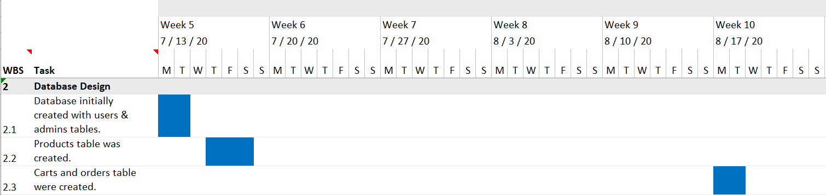

Fig 2.1 Gantt chart of Project Overview & Database Design Phase

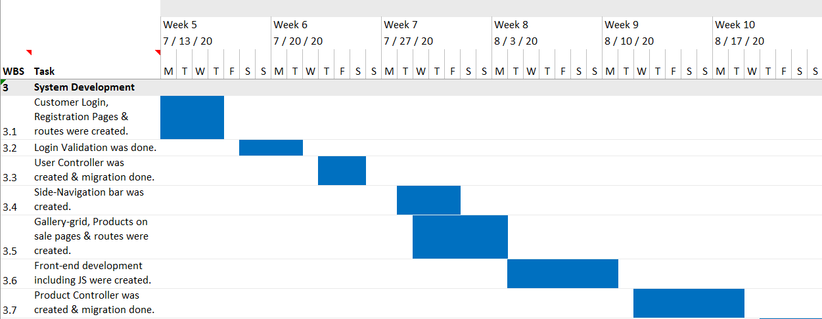

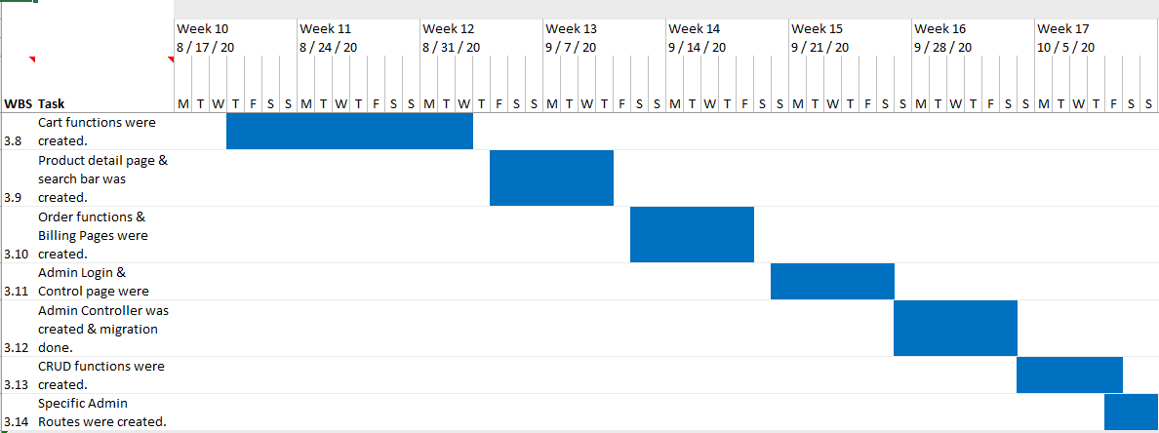

Fig 2.2 Gantt chart of System Development Phase

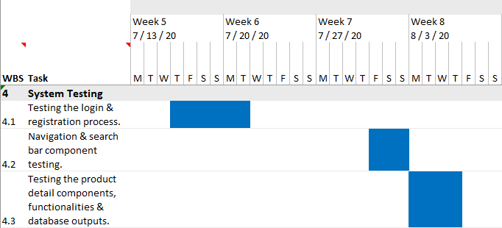

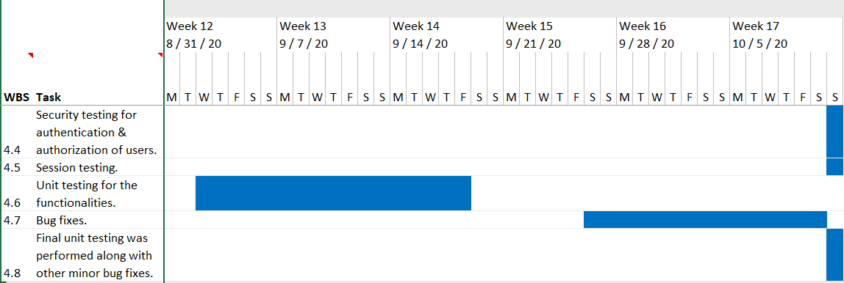

Fig 2.3 Gantt chart of System Testing Phase

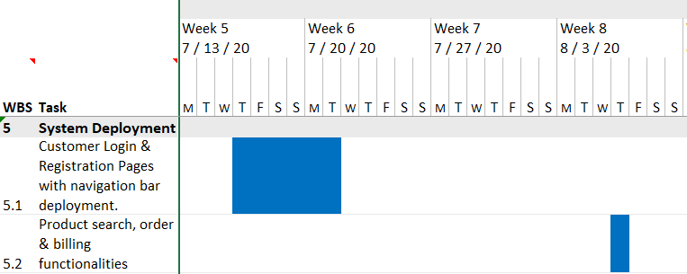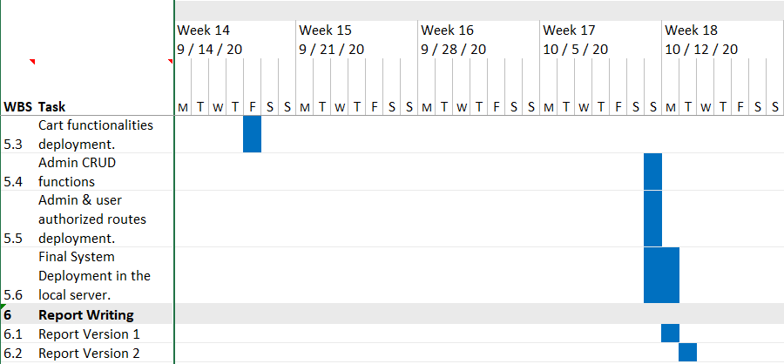

Fig 2.4 Gantt chart of System Deployment & Report Writing Phase

**2.3 System Design**

System design is the process of designing the elements of a system such as the architecture, modules and components, the different interfaces of those components and the data that goes through that system. The purpose of the System Design process is to provide sufficient detailed data and information about the system and its system elements to enable the implementation consistent with architectural entities as defined in models and views of the system architecture.

Below are the different design mechanisms of the proposed “Art Gallery Management System”.

* **Use Case Diagram**

A use case diagram is a graphical depiction of a user's possible interactions with a system. It can summarize the details of your system's users (also known as actors) and their interactions with the system. These diagrams are used to gather the requirements of a system including internal and external influences.

Following use case diagram represents the working of the Art Gallery Management System:

**Customer**

**Art Gallery Management System**

**Admin**

Fig 2.5 Use Case diagram

* **System Flowchart**

A flowchart is a diagram that represents a process, system or computer algorithm. They are widely used in multiple fields to document, study, plan, improve and communicate complex processes in clear, easy-to-understand diagrams. The flowchart below represents the flow of data to and through the major components of the e-commerce system such as data entry, programs, storage media, processors, and communication networks. Flowchart is also known as Data Flow Diagram.

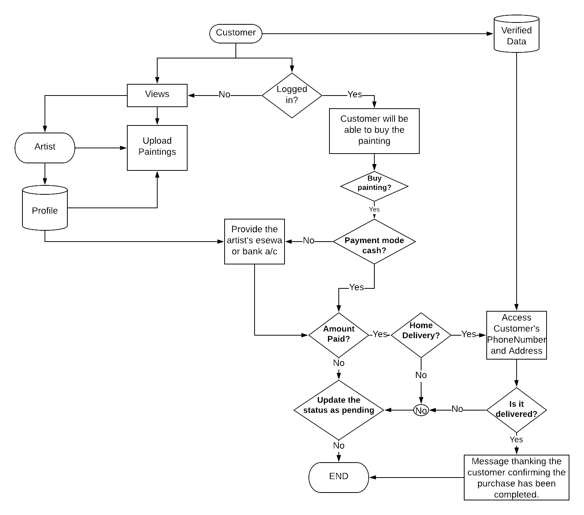

Fig 2.6 Flowchart of the system

**2.3.2 System Architecture**

The following diagram represents the architecture of the system. It describes the systems’ major components, their relationships (structures), and how they interact with each other.

INTERNET



Client Side

Web Server

Database

Server Side

Application Server

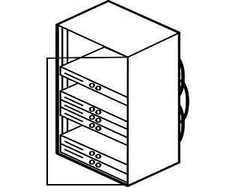

Fig 2.7 System Architecture

**2.3.3 Database Schema Design**

A database schema can be represented in a visual diagram, which shows the database objects and their relationship with each other. A schema contains schema objects, which could be tables, columns, data types, relationships, primary keys, foreign keys, etc.

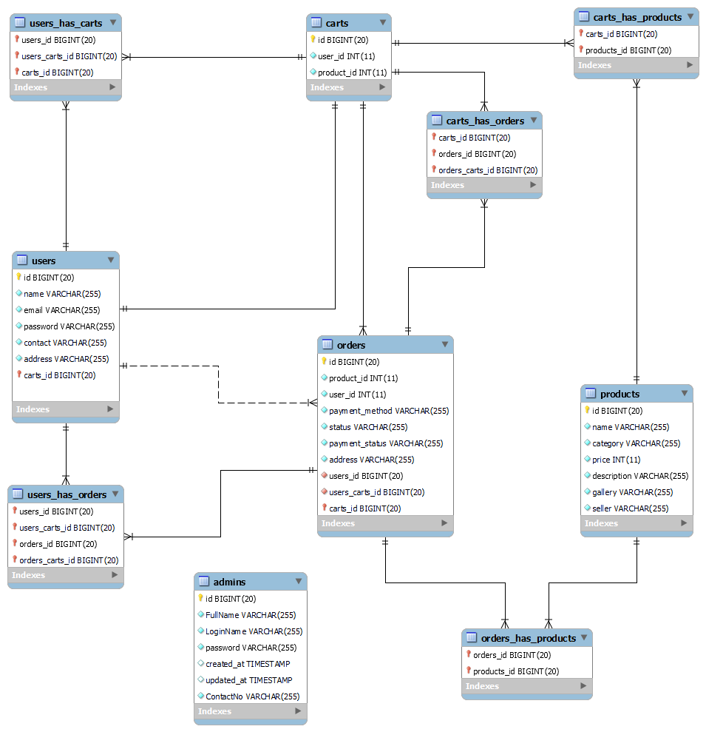

Figure 2.8 Database Schema Diagram

**2.3.4 Interface Design**

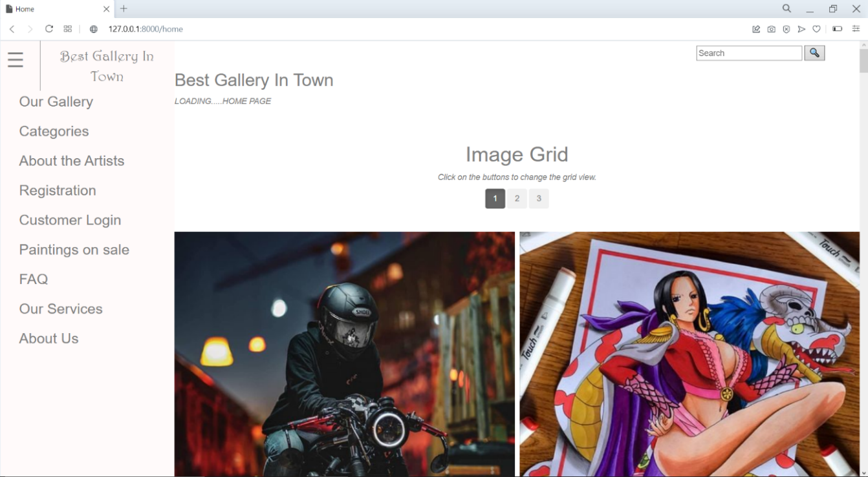

Fig 2.9 Interface Design-Home Page

The UI of this project is designed in such a way that it completely focuses on the easy and pleasurable interaction of the users.

* A side-navigation bar is made available to the users in every page so that it will be easier for the user to navigate through the website.
* Search options, image carousels, sliders and pagination are some other navigational features used to make the website more dynamic.
* The website is designed in such a way that the user shall be able to interact with the objects and manipulate the objects that are present on the screen easily.
* for direct interaction with objects that appear on screen:
* Also, the webpages are designed to be responsive so that it supports all types of devices on any platforms.
* Lastly, according to the survey carried out in the planning phase the theme is set to dark theme as majority of the users preferred the dark theme.

**2.4 Implementation and Testing**

The implementation phase includes installing approved applications into production environments. This phase includes deployment of the project. All the required information needed to run the system and how to use it should be provided in this phase.

For successful implementation of the **Art Gallery Management System** following processes must be considered.

* The web Application can run on any computer with Apache server and XAMPP installed.
* The end users must be provided with all the necessary guidelines and documentations before

using the application.

* Ensure Image Compatibility by making sure that each image is optimized and properly labeled.
* Page title tags and meta descriptions should be checked once the process is complete because they need to be unique, keyword-based, and a certain length to show up properly in searches and links.
* Ensure the all the webpages are Adaptive and Responsive by making sure that it actually works by checking it manually on different devices.
* Make sure that all the authorization and validation of routes are working.

**2.4.1 Coding Tools**

The project was build using the following tools and technologies.

1. **Front End Development**

**•** **HTML CSS, and JS**

HTML is used in the project to create basic page layout. The webpages are styled using CSS and the responsive features are added using JavaScript. The front-end of the project is developed using these three core technologies.

**• Bootstrap**

Bootstrap is used for designing websites and web applications. It is a free front-end framework for faster and easier web development. Bootstrap is used in this project to design some custom components like buttons, tables, forms and other components.

1. **Back End Development**

**• PHP**

PHP is a powerful tool for making dynamic and interactive Web pages. It is a server-side scripting language that is embedded in HTML.PHP itself is an OOP. It is integrated with a number of popular databases like MySQL, Oracle, Microsoft SQL Server, etc. PHP is used in this project as a core programming language to manage dynamic content, databases and session tracking.

**• Laravel Framework**

Laravel is a free, server-side PHP framework which is projected for the development of web applications following the MVC architectural pattern. Laravel is used in this project for managing database migrations and routing, implementing CRUD methods and filtering out the user requests.

**• API**

The Project also has an API that renders JSON data. The API provides GET requests only at the moment and the POST request is handled by the server. The Project uses this API for Views and to generate data Dynamically.

1. **Database**

**• MySQL**

MySQL is an open-source relational database management system based on SQL. The application is used for a wide range of purposes such as data warehousing, e-commerce, and logging applications. There are 5 tables all together in the database for the project.

1. **Server**

**• XAMPP**

XAMPP is a free and open-source cross-platform web server solution stack package developed by Apache Friends consisting mainly of the Apache HTTP Server, MariaDB database, and interpreters for scripts written in the PHP and Perl programming languages. Apache server is used in the Project for the local deployment of the project.

1. **IDE**

**• Visual Studio Code**

Visual Studio Code is a source-code editor made by Microsoft for Windows, Linux and macOS. It is a streamlined code editor with support for development operations like debugging, task running, and version control. Visual Studio Code was used during the development of the project.

**2.4.2 Testing**

Testing is the process of discovering the errors. Testing is intended to show that a program does what is intended to do and to discover program defects. Testing can only show the presence of errors in a program. The testing of the system is to establish the confidence that the software system must be good enough for its intended use. During testing phase different defect are discovered before it is put into the use.

1. **Unit Testing**

Unit testing is the process of testing the individual programs components or object classes. It is necessary to test all features of the object, all operations associated with the objects, set and check the value of all attributes associated with the object.

The following general test cases that have being conducted in the system are:

* Ensuring that admin and customers are able to login the system.
* Ensuring that admin is able to modify and view the user details and their order details.
* Ensuring that admin is able to add, delete and update the product details.
* Ensuring that users are able to logout successfully.
* Ensuring that only the admin can access the admin control panel.
* Ensuring that only registered users are able to use the cart function.

1. **System testing**

In system testing, the whole system is tested to verify that the system performs as its specifications. It focuses on testing the component interactions and object that make up the system. System testing checks that the components are compatible, interact correctly and transfer the right data at the right time across their interfaces. It involves integrating components to create a system or sub-system.

The following system tests were conducted for the project.

1. Test the login mechanism using correct and incorrect logins to check that valid users are accepted and invalid users are rejected.
2. Test the search facility using different queries against known sources to check that the search mechanism is actually finding documents.
3. Test the system presentation facility to check that information about documents is displayed properly.
4. Test the logout mechanism to check if the logged-in user successfully logs out from the session.
5. Test the add-to-cart and remove-from-cart mechanism to check that the user is able to use the cart mechanism only if they are logged-in.
6. Test the order mechanism to check if all the products are displayed correctly with correct billing.
7. Test the admin control panel mechanism to check that only the valid admins are accepted.
8. **Acceptance testing**

Acceptance testing is a test conducted to determine if the requirements of a specification or contract are met prior to its delivery. This was conducted by the end-user, customer, and other stakeholders to validate whether or not to accept the product.

During the acceptance testing of the Art Gallery Management System, following things were checked.

1. UAT was done to determine whether the product is working for the user correctly. Here, specific requirements which are quite often used by the customers are primarily selected for the testing purpose.
2. Alpha Testing was done to address and fix bugs and correct any minor UI issues.

**Chapter III**

**Discussions and Conclusions**

**3.1 Result and discussion**

The making of this project was very challenging, exciting and enlighteningat the same time. I faced many problems, errors and challenges during the course of this project. Moreover, I learned that problems are meant to be solved and the solution of the problem does not arise in front of you until you try to solve it until you put your effort into solving it.

Based on the analysis and interpretation of data, the web application titled “**An Art Gallery Management System**” is able to integrate following functionalities.

* + - The system has role-based login (admin & customer login) and authorities.
    - The system helps to manage details, products on sale and handle accounts of the artists(users).
    - The system has an add to cart and remove from cart functions.
    - The system is able to manage registered user’s data in a systematic way.
    - The system is able to provide user-friendly CRUD functionalities to the admins only.
    - The system provides online billing system to the users so that there is no confusion during the payment process.
    - The system helps authorized admins to view and modify the details of the registered users easily.

**3.2 Conclusion**

For now, this project is centrally administered by an administrator who has privileges to add, update and delete the products directly from the website. All the artists who want to showcase their products must contact the admin to display their products in the website.

The Project entitled “**An Art Gallery Management System**” has been successfully completed by fulfilling with all the requirements and testing scenarios. The project is able to provide all its functionalities to the concerned party i.e., Otaku Art Club. I would also like to thank the club for giving me the opportunity to work on the project which has helped me to enhance my skills to generate creative ideas, face new challenges and tackle down in the real-time. Throughout the development process of the project, I was able to learn a lot of new things and was able to implement my learnings from classes and individual researches too. I feel the completion of this project has offered a great plus point for my portfolio too and I am very satisfied with the end result that I was able to achieve from this project.

As the project leader, I conclude that the project is able to help Otaku Art Club to properly manage its activities through the web application and I hope that the project has succeeded the club’s goal to digitalize their organization. The Project is expected to help the club to bring its user members together and to keep records in a managed system, and also provide proper exposure to the artists.

**References**

Didacus Odhiambo. (2018, Sep 24). System Design in Software Development. Retrieved from:<https://medium.com/the-andela-way/system-design-in-software-development-f360ce6fcbb9>

Satyabrata Jena. (2020, Jun 29). Software Project Development. Retrieved from: <https://www.geeksforgeeks.org/types-of-feasibility-study-in-software-project-development/>

Admin. (2020, Jun 29). Software Project Development. Retrieved from: Satyabrata Jena. (2020, Jul 18). Must Have Features for Ecommerce Website. Retrieved from: <https://www.geeksforgeeks.org/types-of-feasibility-study-in-software-project-development/>

Lucidchart. Flowchart Design. Retrieved from <https://lucid.co/product/lucidchart>

Documentation. Retrieved from <https://laravel.com/docs/8.x>

Christensson, P. (2011, July 26). Navigation Bar Definition. Retrieved from <https://techterms.com>

PHP Tutorial. Retrieved from <https://www.w3schools.com/php/>

Anil Sidhu aka Code Step By Step. (2020, Sep 8). Laravel Tutorial. Retrieved from <https://www.youtube.com/playlist?list=PL8p2I9GklV46dciS4GDzBFHBi0JVIbnzT>

**Screenshots:**

